Remote

Solar Powered

(with battery backup)

Soil Moisture Sensor

ASSEMBLY

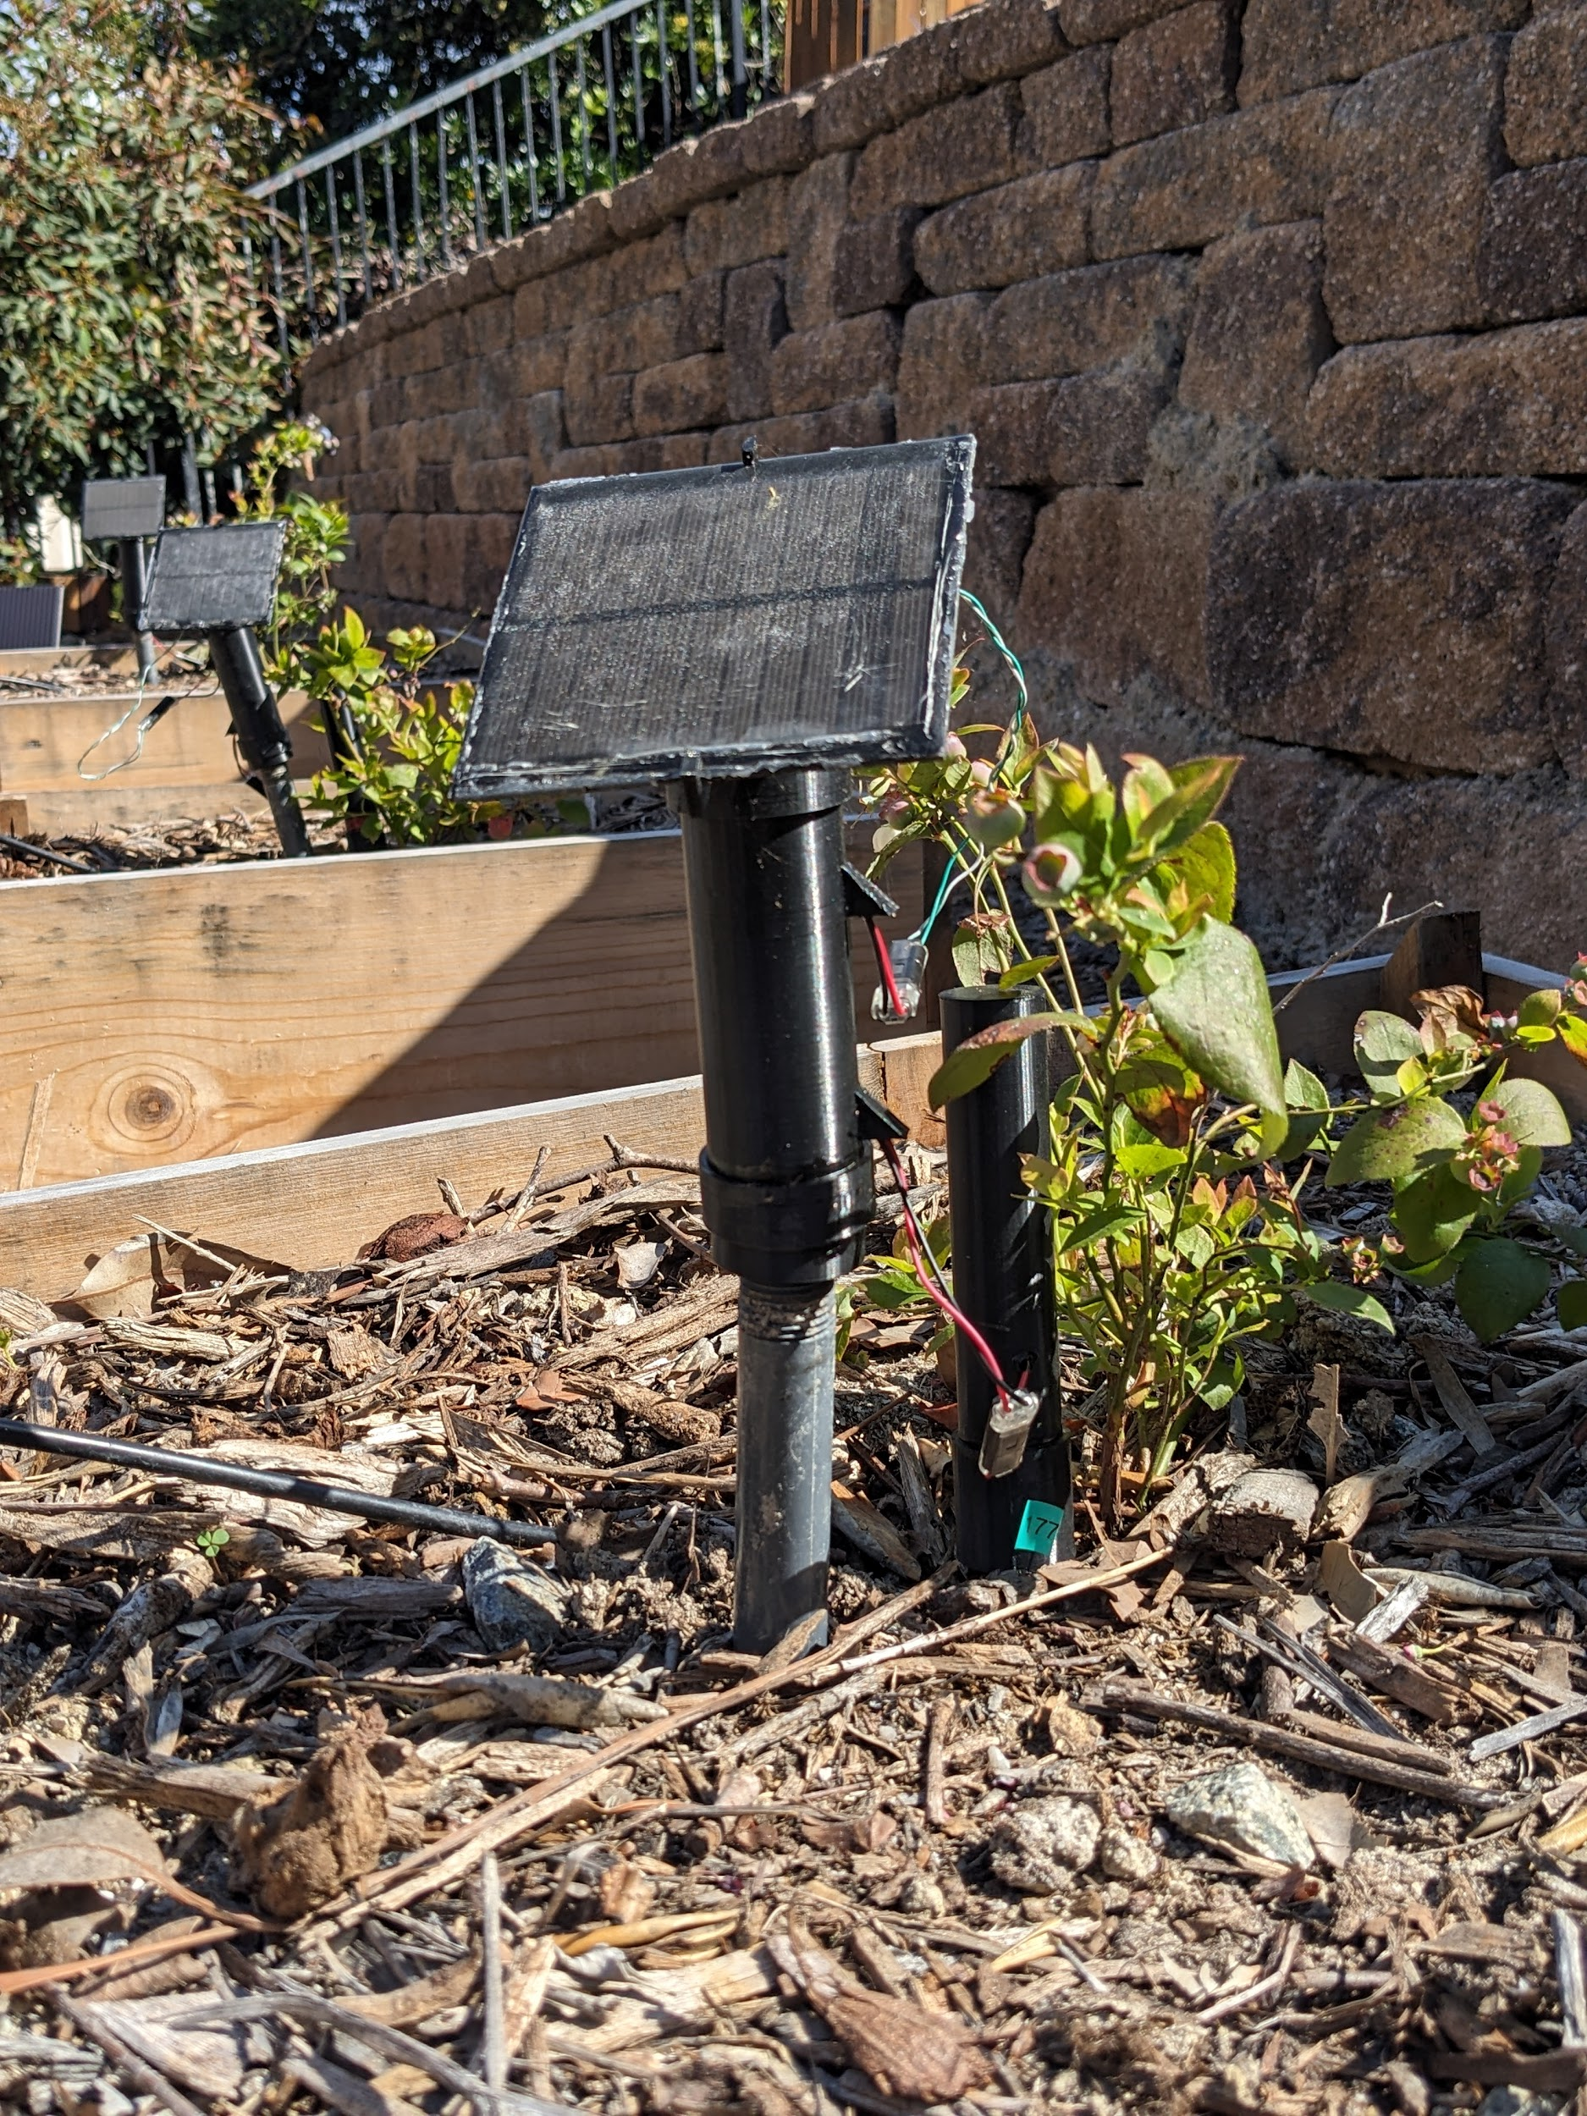

# Tools and consumables

* 1. Soldering suitable surface
  2. Soldering iron
  3. Solder
  4. [Adjustable power supply](https://www.amazon.com/dp/B00BYTEHQO) with [12V adapter](https://www.amazon.com/Adapter-100-240V-Transformer-Charger-Security/dp/B091XSVV1Y/ref=sr_1_3)
  5. [Clear Lacquer](https://www.amazon.com/Sprayon-ELECTRICAL-LACQUER-Aerosol-S02000000/dp/B00DRHSFCS)
  6. Superglue
  7. Sealant

# Prepare micro controller

Note the orientation of the pins. These are placed in this direction to keep the pin connectors connected while sliding the assembly into the nano tube

* 1. Solder J9-15 to the micro controller

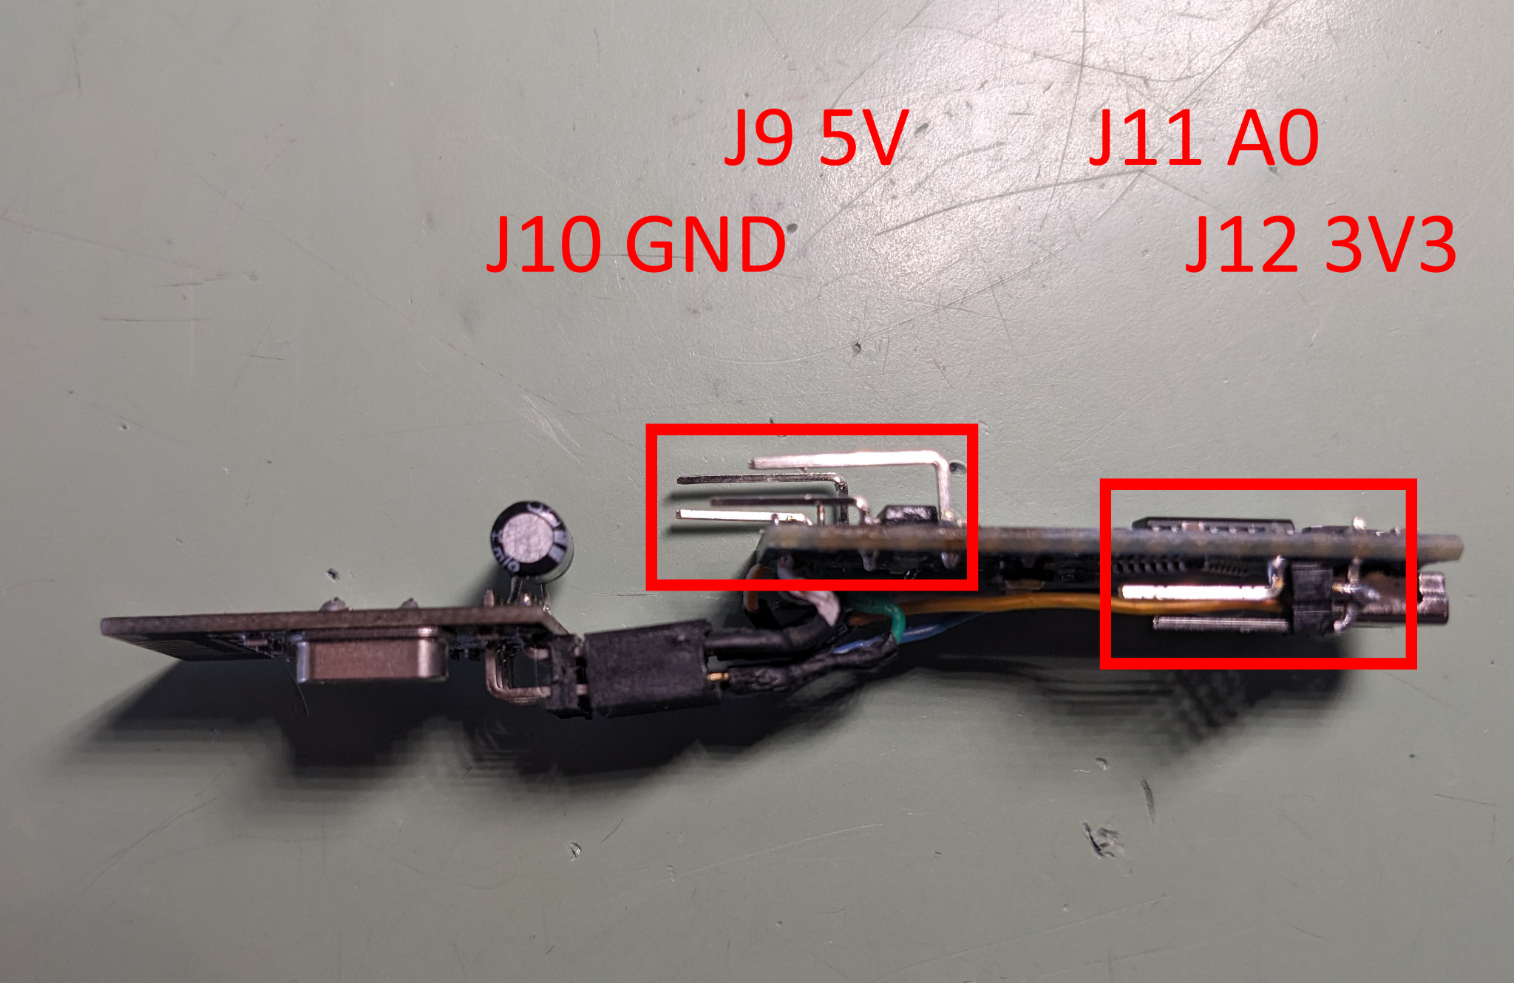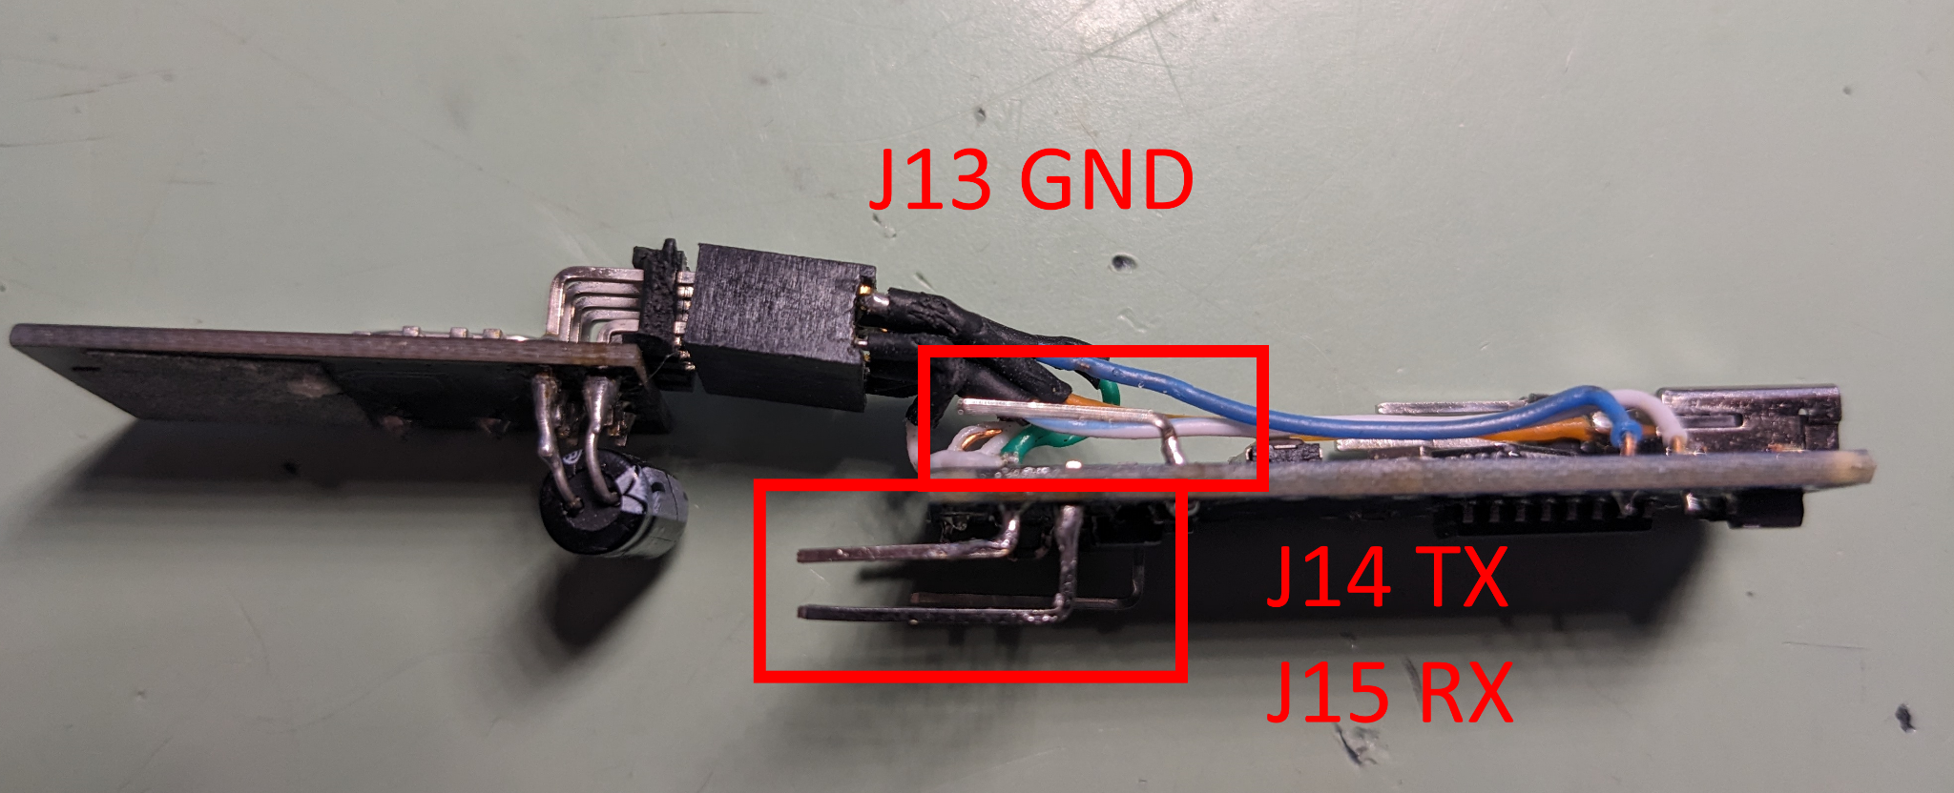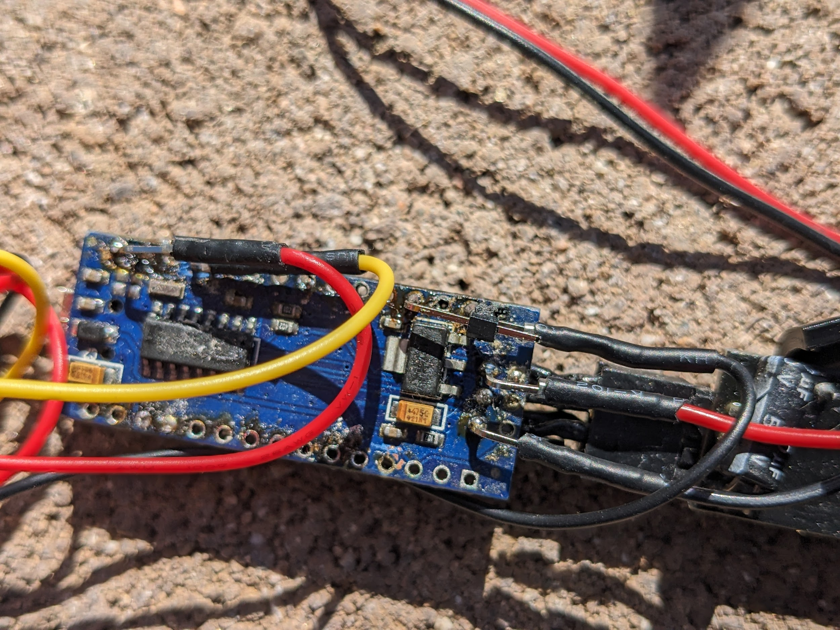

* 1. If U1 is the RF Nano, skip to next step
     1. Connect the radio to the Nano per these [instructions](https://www.mysensors.org/build/connect_radio)
  2. Program the Nano
     1. Use an appropriate program to set address 0 of the Nano EEPROM to the value of the node desired for this sensor. addressAsUint8_t_1_00.ino will do this.
     2. Download the program into the Nano
        1. The program may require changes for your system
           1. CE and CS are set for the RF Nano

#define MY_RF24_CS_PIN 9

#define MY_RF24_CE_PIN 10

* + - * 1. RF channel

#define MY_RF24_CHANNEL 121

# Prepare battery carrier and charge board

* 1. Similarly solder the 4 right angle connectors to the charge board at +, -, OUT+ and OUT-

.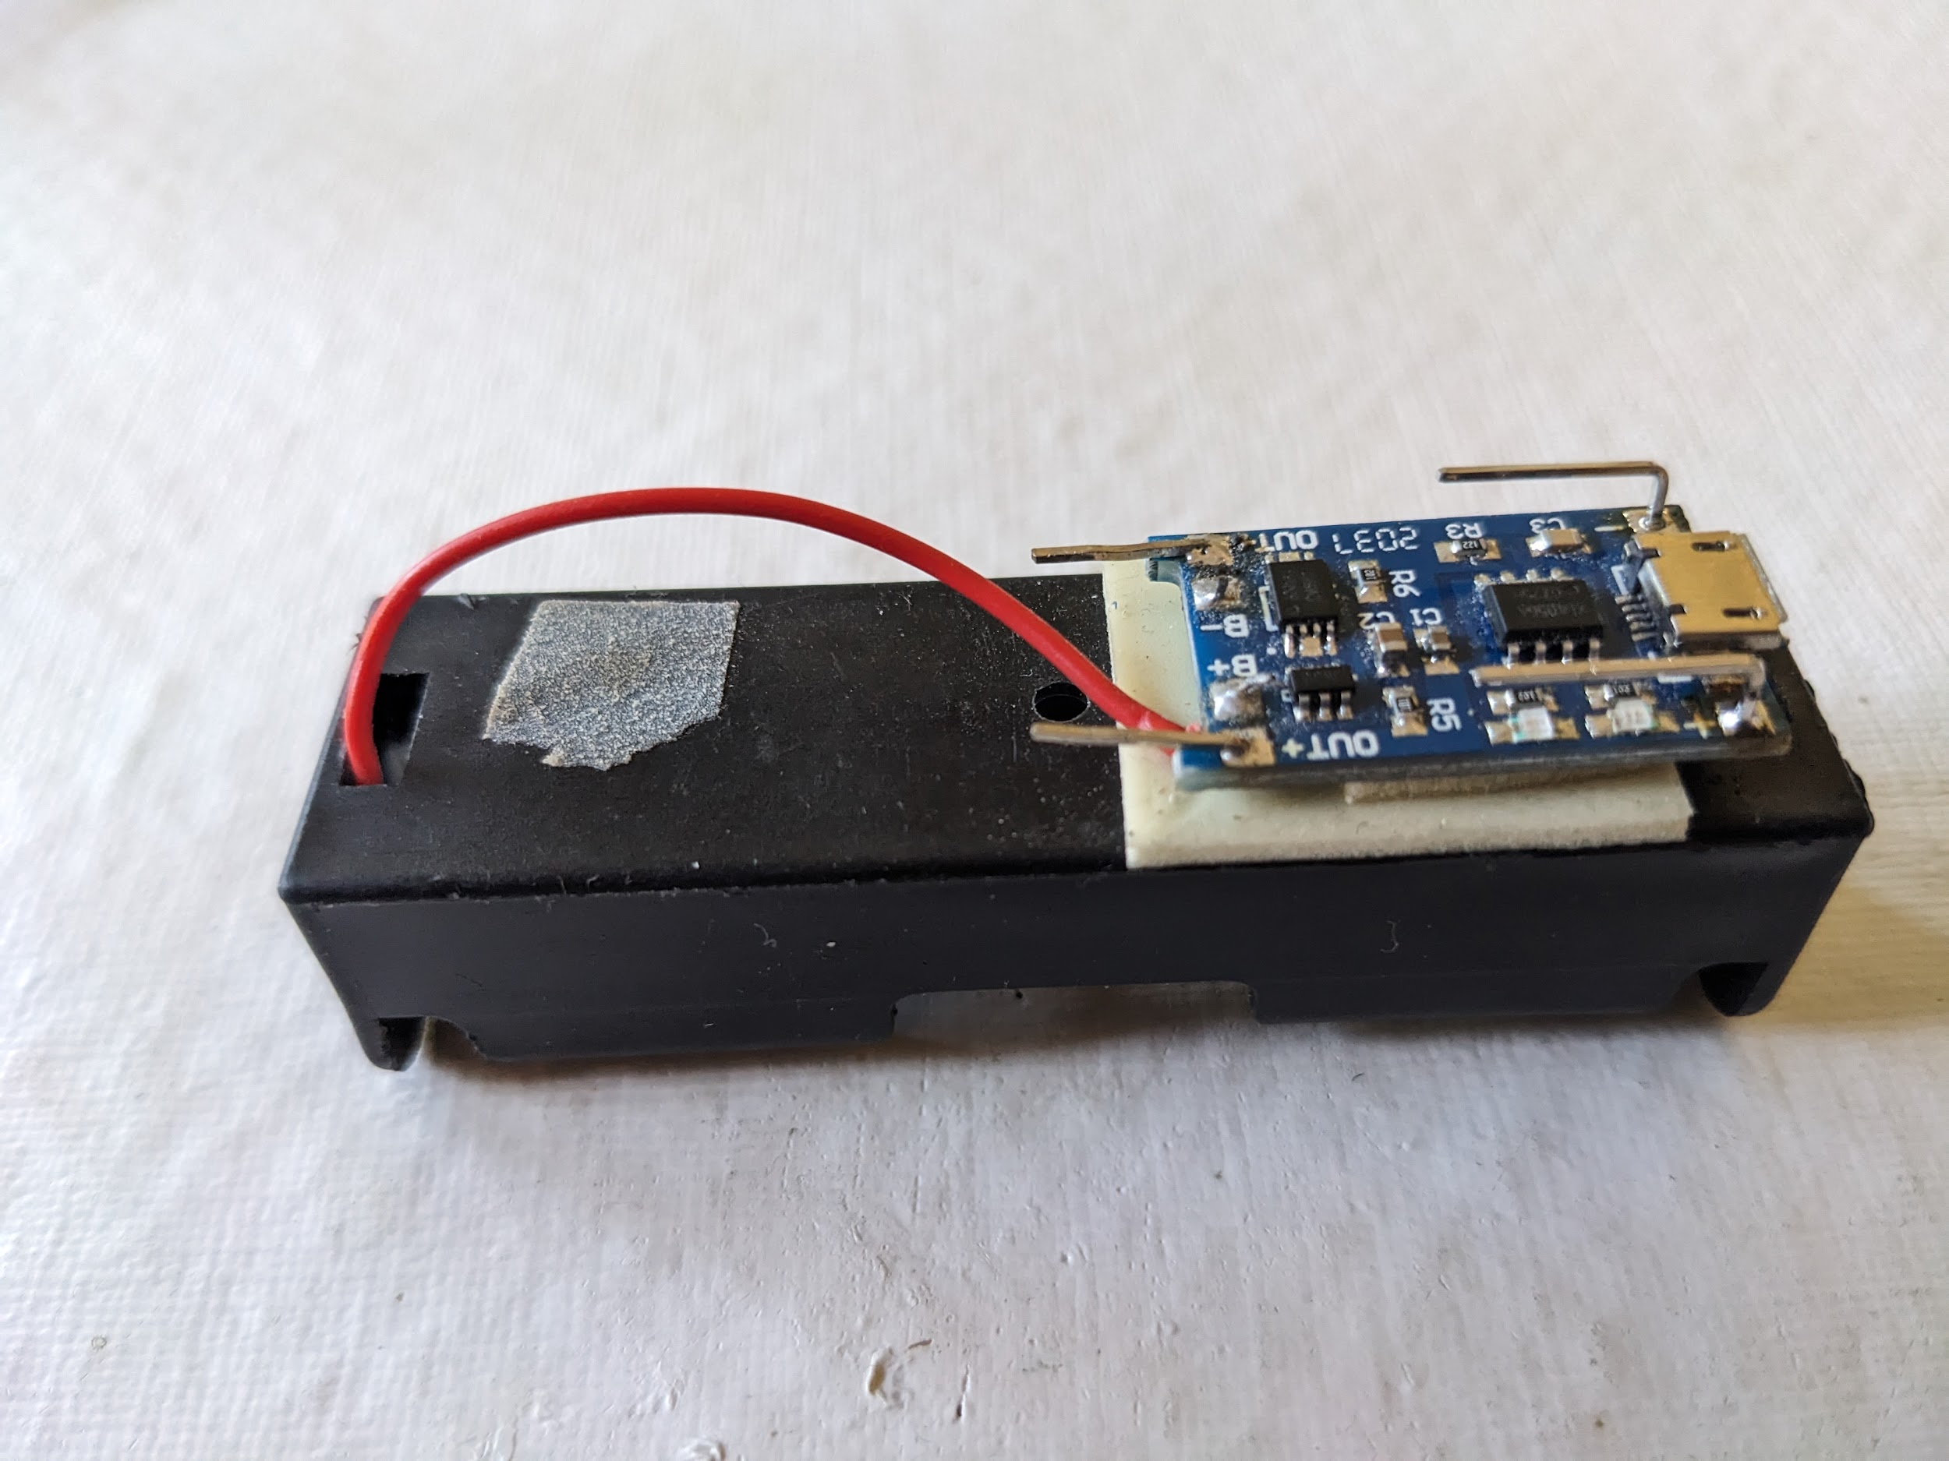

* 1. Solder the red wire of the carrier to the B+ and the black wire to the B-
  2. Attach the charge board to the battery carrier with double stick tape

# Prepare the connecting wires

* 1. Solar Panel wires.
     1. Put 20mm of 1mm heat shink tubing over the solar panel wires
     2. Cut 1 F-F wire in half
     3. Strip about 5mm of each of the four wires, 2 from the solar panel and the two halves.
     4. Bend the stripped portion of the wires 180°.
     5. Hook the stripped part of a solar panel wire and F wire. Make sure that the two wires result in a diameter less than the heat shrink tube
     6. Solder the wires, let cool
     7. Slip the heat shrink tubing so that it covers the insulation of both wires.
     8. Repeat for the other two wires
     9. Shrink the tubing with heat (heat gun is best)
     10. Secure the wires to the solar panel by taping them flat against the back of the panel, leaving about 5cm of wire free for connecting to the battery.
  2. Solar Panel to charge board: 2 wires M-F
     1. In order to get the wire into the hole in the tube, the female connector covering needs to be removed. This is done by pushing the wire into the covering, lifting the retaining tab, and pulling the wire out.

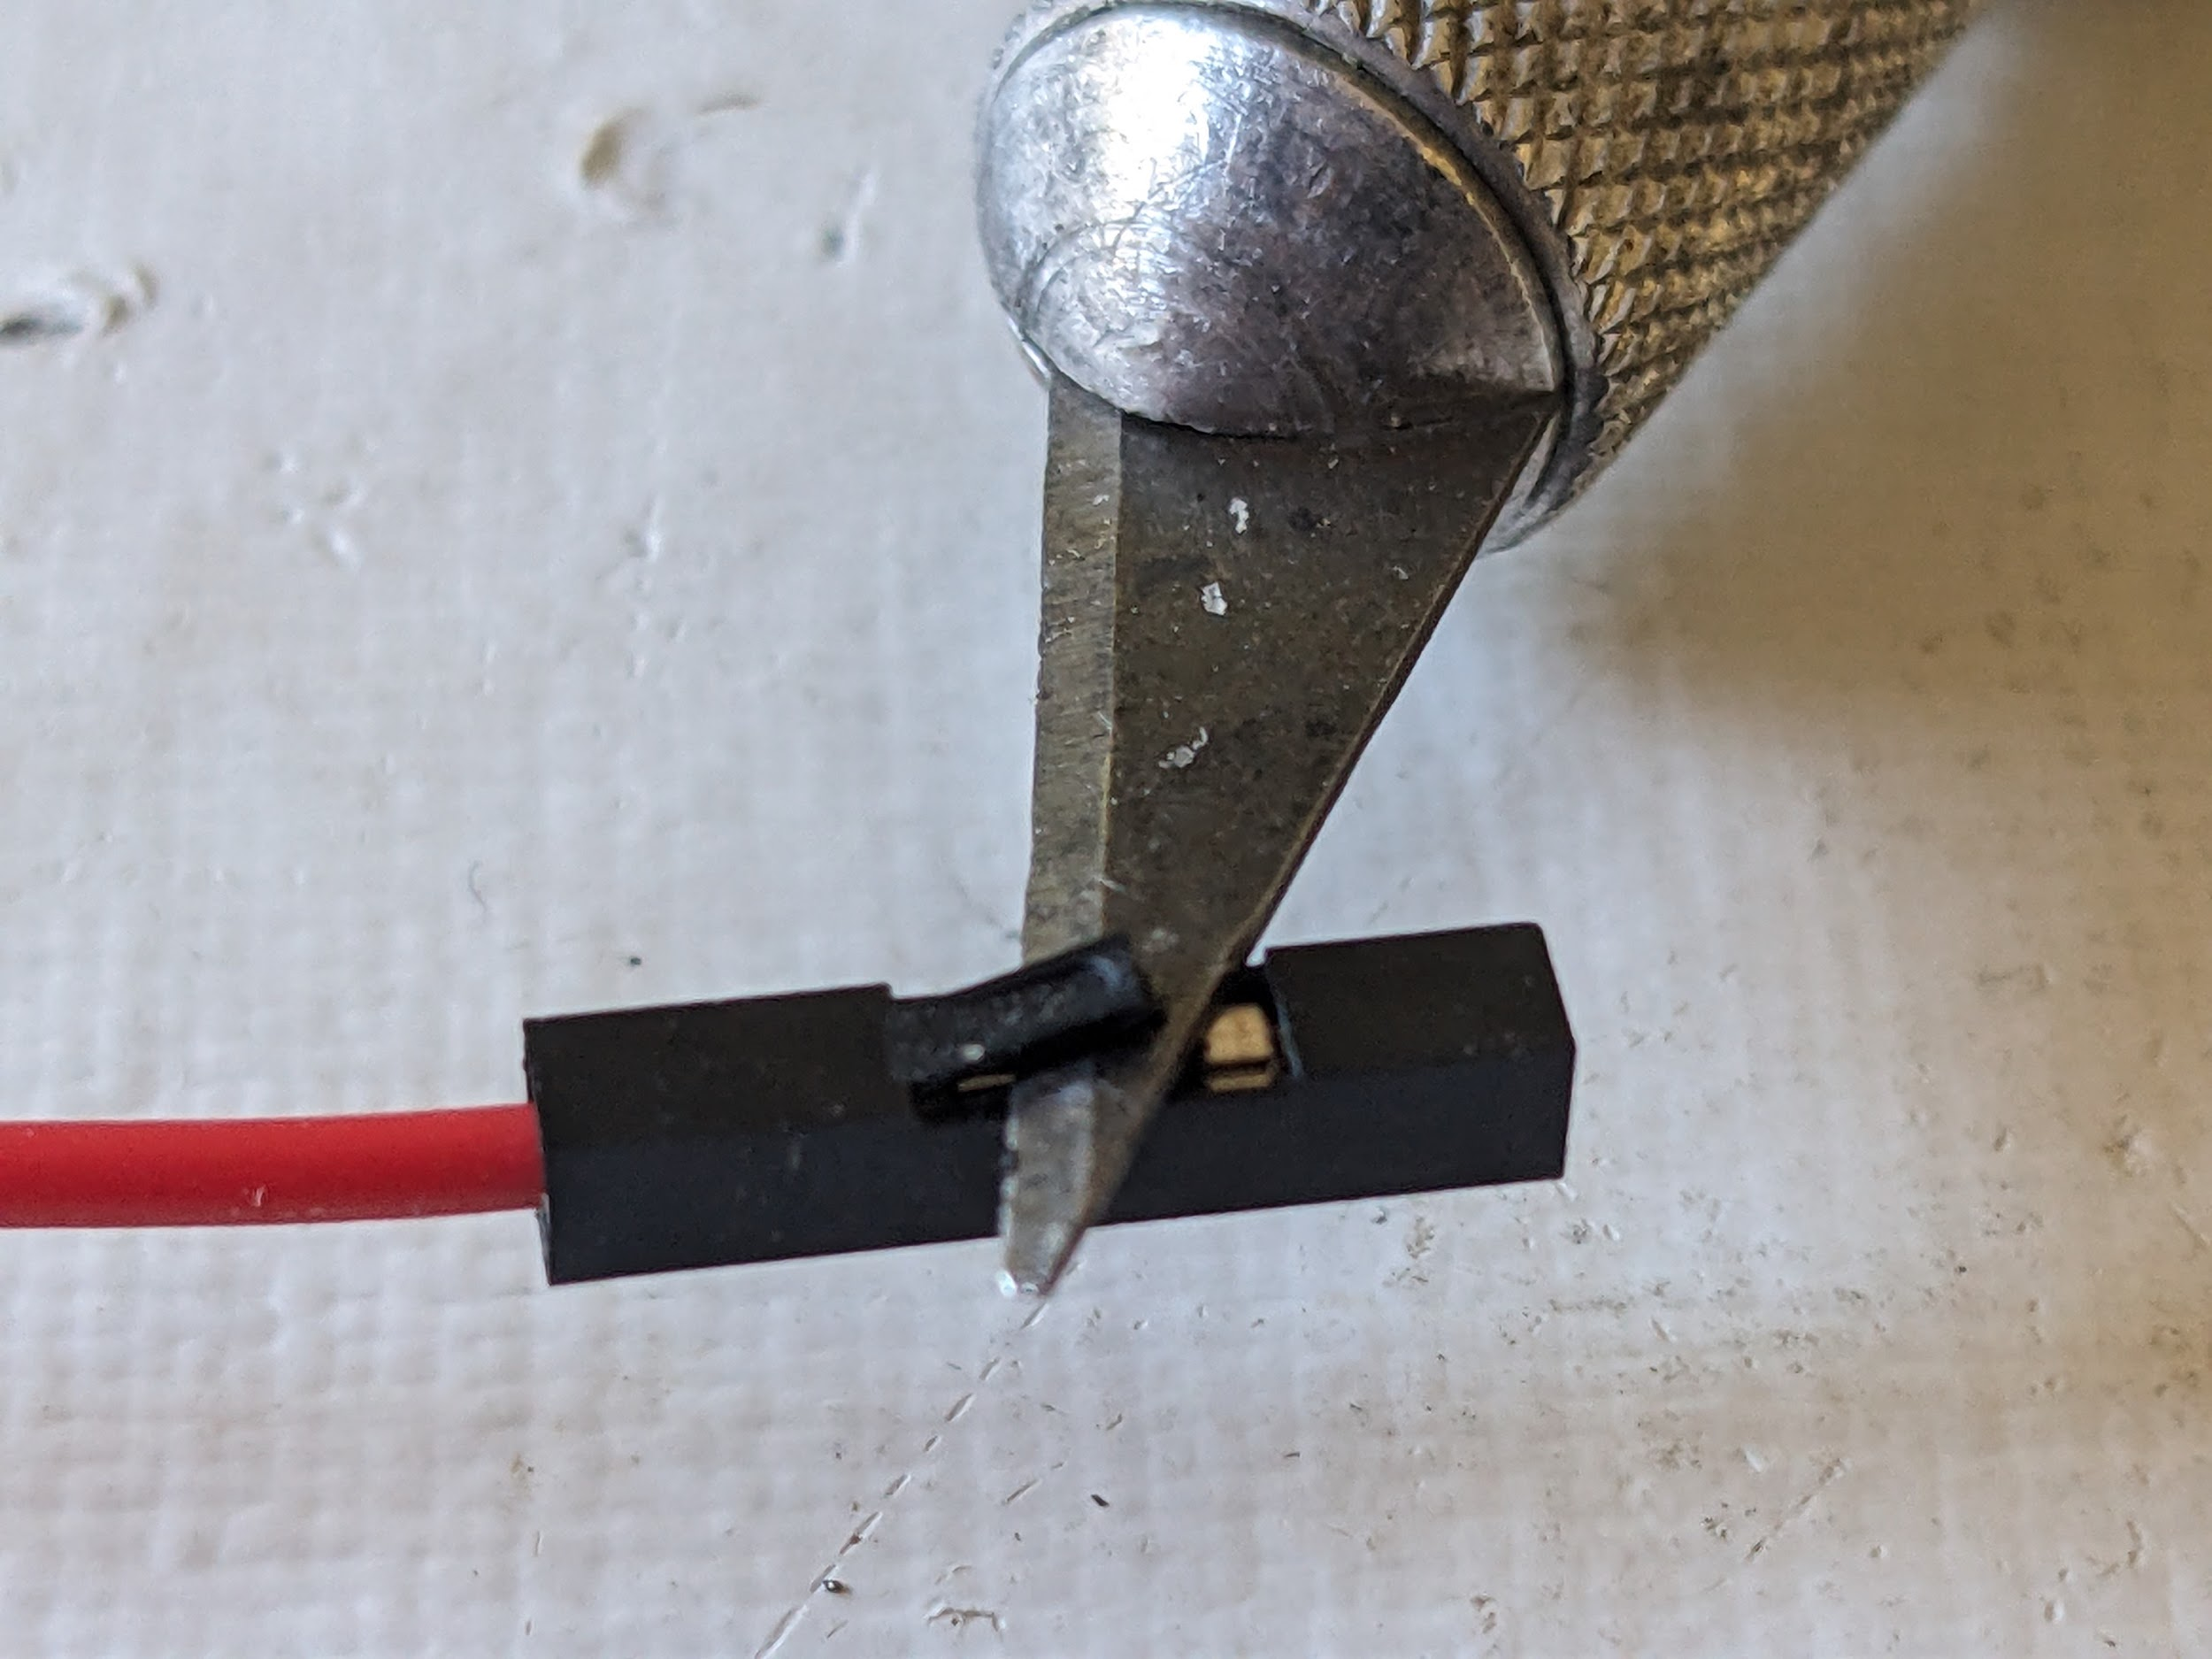

* 1. Shrink the tubing with heat.

1. The two charge board to Nano wires F-F are prepared similarly, but only one end of each of the two wires wire
   * 1. Heat shrink tubing provides insulation to prevent shorting to other components. Slide 10mm of 2mm heat shrink tubing over the exposed connector.The two Nano to charge board wires M-F are also prepared similarly
   1. The three Nano to moisture sensor wires are in one covering but prepared in a similar fashion.

# Running the wires.

The prepared F ends of the wires, one at a time, will be pushed up into the holes and pulled out of the open (bottom) end of the tube. Pull about 5cm of wire past the bottom of the tube.

* 1. The hole at the top battery tube is for the *charger to solar panel* pair of wires (M-F)
  2. The hole at the bottom battery tube is for the *charger to Nano* pair of wires (F-F)
  3. The hole in the Nano Tube is for the *Nano to charger* pair of wires (M-F)

# Connecting the wires.

The most difficult part of connecting the wires is remembering which wire was connected to which connector. I use red wire for + , VCC or 3V3 and black wire for - or GND. The yellow wire of the moisture sensor is a signal wire to be connected to the A0 connector of the Nano.

**NOTE: THE CONNECTORS ON THESE WIRES ARE PRETTY MUCH A “*ONE TIME CONNECT*”** So get it right the first time. The can be crimped a little, but it’s a losing battle. In a later step you will be spraying on clear lacquer, this helps a little, A dab of liquid tape on the connection will help a bit more.

1J (+ of charger) red wire, upper hole of battery tube

J1 ( - of charger) black wire, upper hole of battery tube

J3 (OUT + of charger) red wire, lower hole of battery tube

J3 (OUT - of charger) black wire lower hole of battery tube

J10 (5V of Nano)red wire

J9 (GND of Nano) black wire

J11 (A0 of Nano) yellow wire

J12 (3V3 of Nano) red wire

J13 (GND of Nano) black wire

The connector to the sensor is keyed

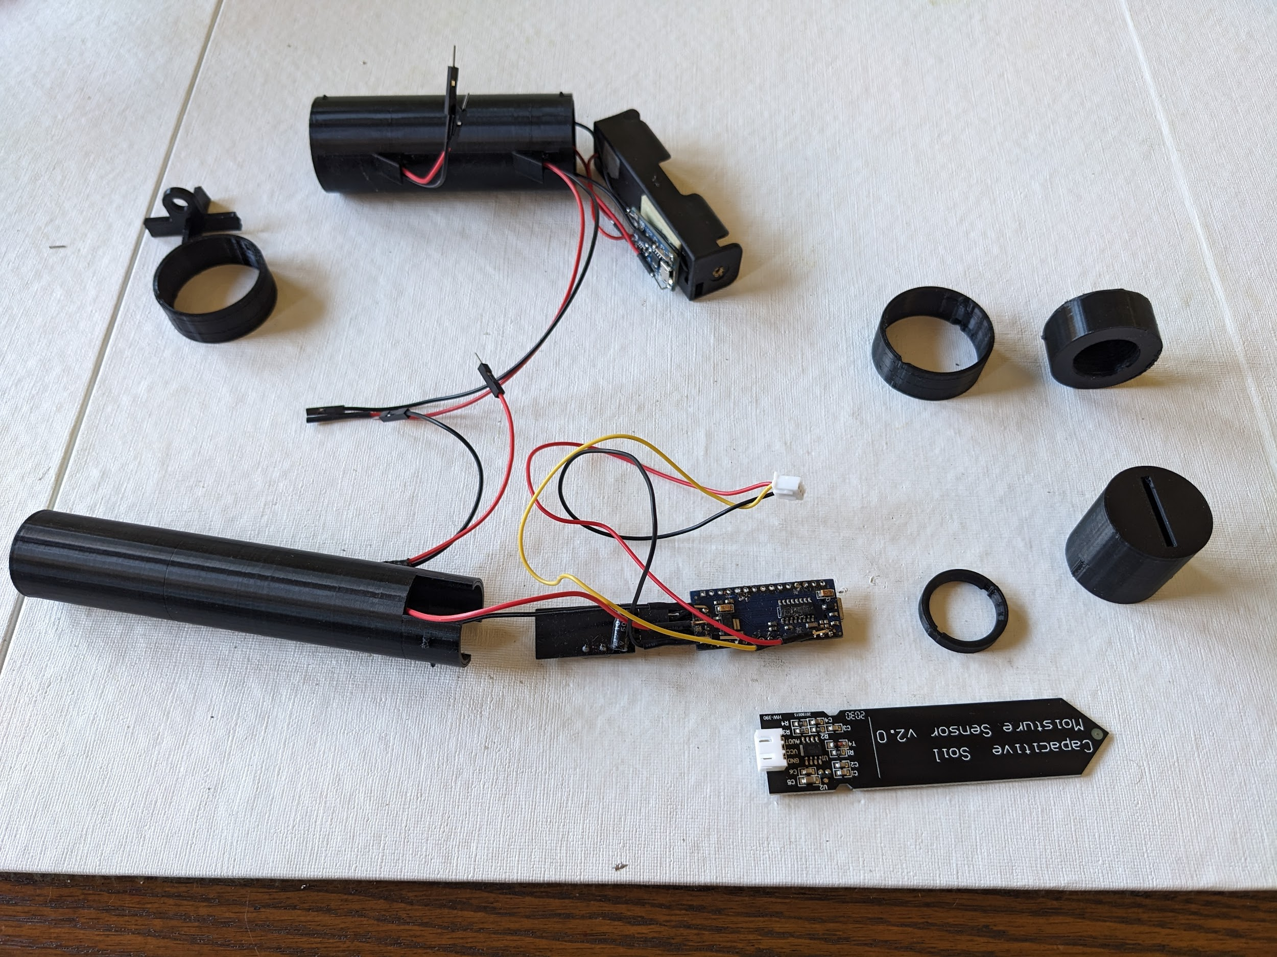

* 1. The hole at the top battery tube is for the *charger to solar panel* pair of wires (M-F)

# Corrosion prevention

Now is the time to spray the clear lacquer onto all of the electronic components, taking care to get little or no lacquer on the inside of the USB connector.. After the lacquer dries, put a dab of liquid tape on the contacts.

# Nano tube and sensor tube assembly

* 1. Note that the edge of the sensor tube has two notches, the connector of the sensor goes nearer to the single notch. Slide the sensor through the notched holes of the sensor keeper, At the notch in the sensor, turn the keeper 90°.
  2. Slide this assembly into the sensor tube. The depth line on the sensor should be barely visible.
  3. Pushing the Nano into the nano tube gets a little tricky. As the Nano slides up into the tube, the wires have the slack taken up until they reach the hole, and then slack given as the Nano is pushed in further. (And hope that the connections don’t come loose.)
  4. This would be a good time to check to see if the Nano turns on.
     1. Connect +5V to the red wire and ground to the black wire. The LED of the Nano should come on.

* + 1. Assuming that the program on the Nano will connect to the MySensors Gateway and the MySensors Integration is installed and functional in Home Assistant, the device information should be found in Home Assistant: Settings→Devices & Services→nn DEVICES of MySensors→RSMoistureSens NNN (where NNN is the node ID)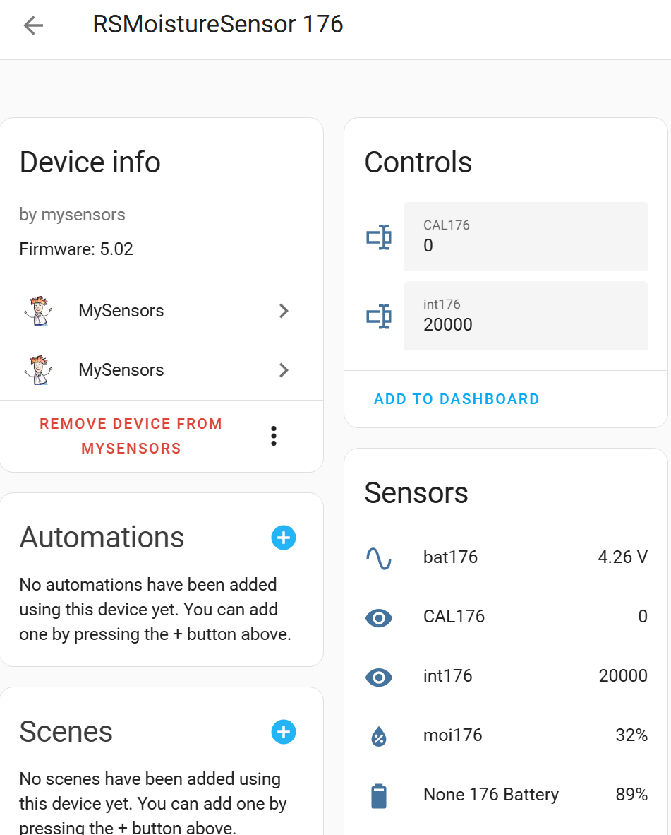
  1. Coil the wire of the sensor into the nano tube (as best you can). Slide the Nano into the sensor tube, aligning the tabs of the nano tube with the notches of the sensor tube.
  2. When fully seated, twist the tubes counterclockwise.

# Battery tube assemble

* 1. Put the 18650 rechargeable battery into the battery carrier.
  2. In a similar fashion of the Nano, slide the battery carrier into the battery tube
  3. On each end of the tube, slide a coupler, aligning the tabs with the notches. The coupler will seat, then turn the tube counterclockwise in the coupler
  4. Similarly, slide the ½” plug into the bottom coupler
  5. Slide the cross piece onto the mount
  6. Like the plug, slide the mount/cross piece assembly into the top coupler, turn counterclockwise to set.

# Calibration procedure

* 1. Tools:
     1. A cup filled with water so that, when the sensor is in the cup, the water fills almost to the depth line, but definitely not more!
     2. Variable power supply
     3. It is assumed that the program on the Nano will connect to the MySensors Gateway and the MySensors Integration is installed and functional in Home Assistant.
  2. Wipe the sensor dry
  3. Set the power supply to 4.2V and connect the + of the power supply to the red wire and - to the back wire
  4. The device should connect to Home Assistant, see above.
  5. Move to the device just created: In Home Assistant→Settings→Integrations→”nn Devices of MySensors”-->RS SoilMoisture Sensor nnn
  6. Change calibration mode by entering the value **intnnn** to 2000 (milliseconds) This will change the sample period to 2 seconds.
  7. Change the value of **CALnnn** (where nnn is the node number) to 1. This will set the first constant
  8. Set the power supply to 3.3V
  9. Change **CALnnn** to 2 This will set the second calibration constant
  10. Immerse the sensor in the water
  11. Wait for the value **moinnn** to stabilize (eg, only changing 1%)
  12. Change **CALnnn** to 3 This will set the third calibration constant
  13. Set the power supply to 3.3V
  14. Change **CALnnn** to 4 This will set the fourth calibration constant
  15. Change **CALnnn** to 0 and change the value **intnnn** to 2001, This will end the calibration.
  16. This may be a good time to set the sample interval. Set the value of **intnnn** to the sample interval desired. This number is in milliseconds. Eg. 2001 is 2.001 seconds.

NOTE, if you change the value of **CALnnn** or **intnnn**, it takes 2 intervals for the value to become effective. If the interval is an hour, it takes two hours for the device to respond.

* 1. Turn off the power supply and disconnect from the device.

# Weather resist the sensor

* 1. Using liquid tape, seal where:
     1. the sensor protrudes from the sensor tube
     2. the sensor tube and nano tube join
     3. the wires enter the sensor tube
     4. The joint between the plug and coupler
     5. The joint between the coupler and the battery tube
     6. the wires enter the battery tube

# Deploy the sensor

* 1. The sun and wind and rain will conspire to degrade the sensor, particularly the exposed wires. It is acknowledged that this is a weak point of the design. Please be aware of this likely point of failure.
  2. After the solar panel bracket is carefully attached to the solar panel, attach the assembly to the top of the battery tube with the 5mm bolt and nut. You will probably find that the 3D printed bolt and nut are not functional. Thus the recommendation of a stainless steel bolt and nut.
  3. The ½” plug, though, does conveniently screw onto a ½” ntp thread pipe, such as various lengths of common ½” threaded nipples that are used in irrigation plumbing. This nipple can act as a stake for the battery/solar panel assemble.
  4. Typical soils used in cultivation are amenable to having the sensor pushed into the soil with little effort.
  5. Once the area to be sampled is selected, an adjacent sunny location for the solar panel, connect the battery wires to the solar panel.
  6. Adjust the solar panel for optimal sun radiation collection.
  7. Seal all the wire connections with liquid tape
  8. At this point, the relative soil moisture will be sent to the home automation controller.